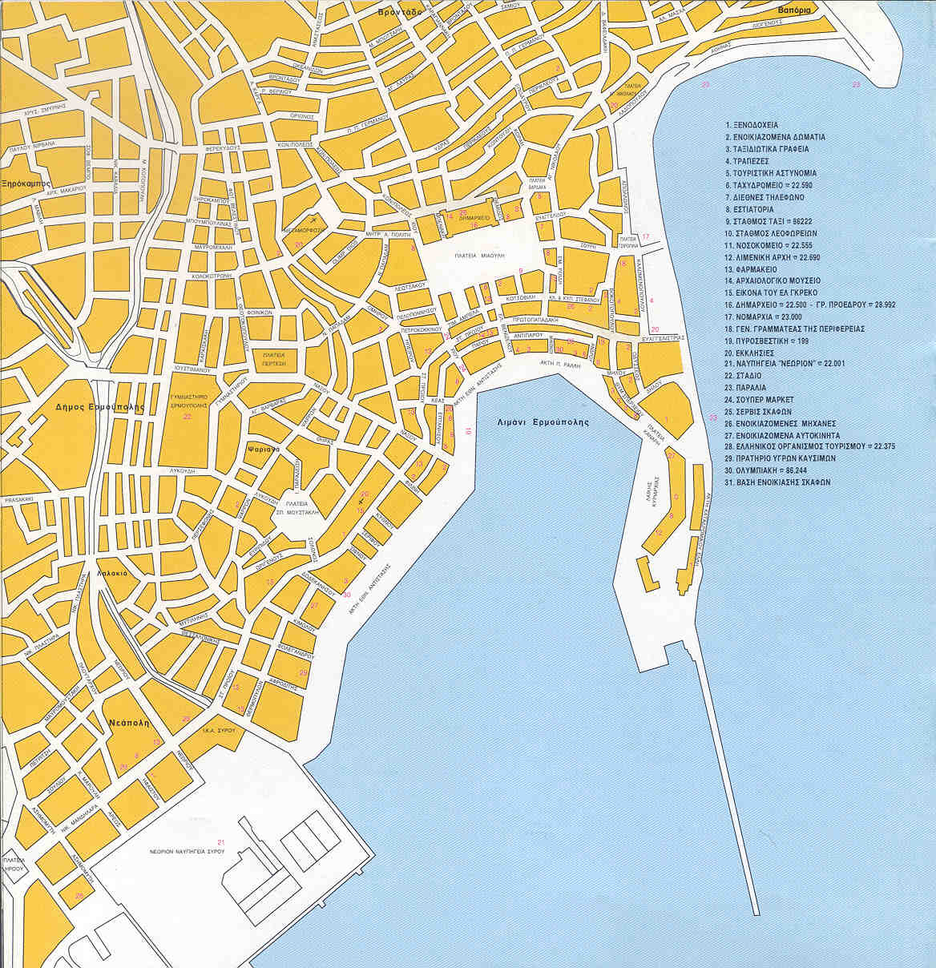
Harbour
(Λιμάνι)
University
(Πανεπιστήμιο)
100 m
CulturalCenter

Hotel
Aegli
Hotel
Palladion
Hotel
Philoxeno
Hotel
Kymata

